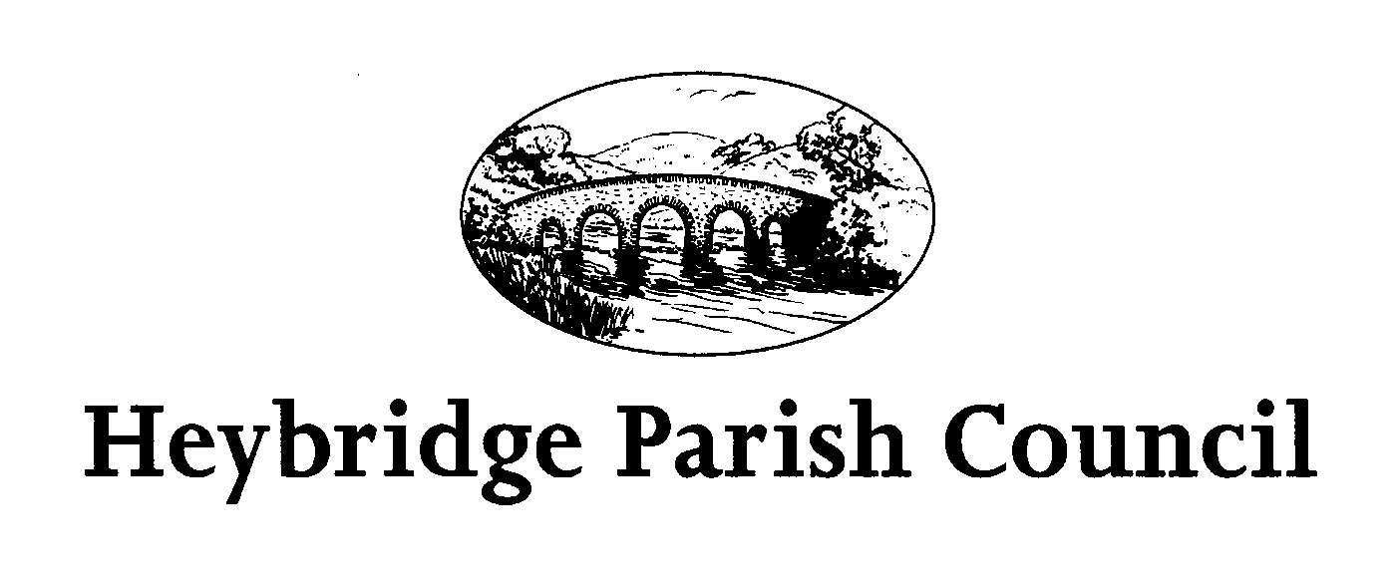
The Public and Press are invited, and all Councillors are summoned, to attend the forthcoming Parish Council Meeting of Heybridge Parish Council. The meeting will be held on Monday 17th November 2025 at 7.30pm in the Main Hall, Plantation Hall, Colchester Road Heybridge where the under-mentioned business is proposed to be transacted.
Recording of meetings
Please note the Council may be recording any part of this Meeting held in open session. Members of the public attending the Meeting with a view to speaking are deemed to be giving permission to be included in the recording.

Amanda Hilton
Amanda Hilton
Clerk to Heybridge Parish Council 11th November 2025

AGENDA

- Chairmans Welcome

- Apologies
To receive apologies.

Minutes
- To receive and confirm the Minutes of the Parish Council Meeting held on Monday 20th October 2025 (Appendix 1)
- To receive the DRAFT Minutes of the Environment, Facilities and Finance Meeting held on Monday 27th October 2025 (Appendix 2)
- To receive the DRAFT Minutes of the Events Committee meeting held on Monday 10th November 2025 (Appendix 3)
- To receive and approve the DRAFT Minutes of the Budget Committee meeting held on Wednesday 15th October 2025 (Appendix 4)

Interests
To receive declarations of interest in accordance with the council’s Code of Conduct. Unforeseen interests must be declared similarly at the appropriate time.

- Public Participation
Members of the Public will be given an opportunity to put forward their question(s) or statement to the Council. The Chair will at his discretion then decide if he is able to answer the question(s) or proposes to put the item on the agenda for the next meeting.
6 To receive reports from:
a) District and County Councillors (to be circulated)

7. Committees, Working Groups and Representatives.
a) To receive a report from the Chair of the Events Committee regarding upcoming events. To consider plans for Baby Loss Awareness Week October 2026.
b) To receive a report from the Chair of the Environment, Finance and Facilities Committee.
c) To receive an update from the Communication Working Group.
d) To receive an update from the Heybridge in Bloom Working Group.

8. Consultations and Policies
a) To note the Community Governance Review has been advertised. The Clerk to report.
https://www.maldon.gov.uk/.../community_governance_reviews
b) To consider actions required to confirm compliance (GDPR and DPA for security and privacy, FOI & Transparency Code for document publishing, and digital compliance) Assertion 10 Smaller Authorities’ Proper Practices Panel (SAPP) Clerk to report (to be circulated)

9. Planning Application
To consider submitting comments on planning application
Application: 25/00940/LDP
Proposal: Claim for lawful development certificate for a proposed single storey rear extension.
Location: 3 Regency Court.

10. Clerks Report (to be circulated)
a) To receive an update from the Clerk regarding current and on-going matters and consider actions to be taken.

11. Financial Matters
a) To receive updated statement of accounts for November 2025 (to be circulated)
b) To receive the bank reconciliation for October 2025 (to be circulated)
c) To receive and consider schedule of payments including invoices and
accounts for payments for 17thNovember 2025 (to be circulated)
d)To note precept request for 2026/2027

12. Local Issues
a) To note any items for inclusion on the Agenda for Monday 19th January 2026

13. Correspondence
a) To note correspondence received any actions to be taken.

Due to confidential business, this meeting is not open to the press or members of the public (Public Bodies (Admissions to Meetings) Act 1960, s1 (2)).

14. Thursday Lunch Club
a) To receive a report regarding the Thursday Lunch Club and consider actions to be taken. (to be circulated)

15. Future Meetings
a) The next meeting of the Environment, Finance and Facilities Committee will be held on Monday 24th November 2025 at 7.00pm.
b) The next meeting of the Planning Committee will be held on Monday 1st December 2025 at 7.00pm.
c)The next meeting of the Events Committee will be held on Monday 8th December 2025 at 7.30pm.- Christmas Fayre only.
d)The next meeting of the Parish Council will be held on Monday 19th January 2026 at 7.30pm.

