
Community Litter Picks
are being held on:

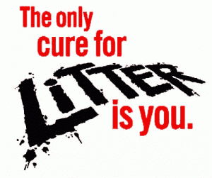
Sunday 22nd September

Sunday 13th October
Sunday 17th November
Meet at Plantation Hall at 10.00am.
Heybridge Parish Council will provide gloves, litter pickers and bin bags, all YOU need to do is turn up and help us keep our parish tidy.
Refreshments will be served.

