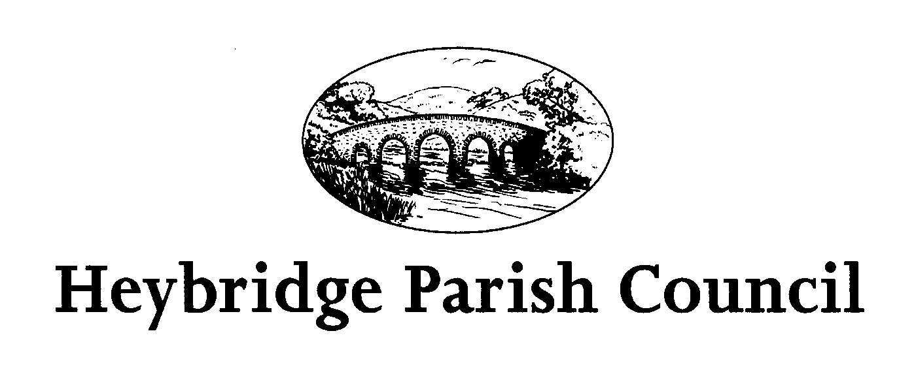
The Public and Press are invited, and all Councillors are summoned, to attend the forthcoming Parish Council Meeting of Heybridge Parish Council. The meeting will be held on Thursday 2nd January 2025 at 7.30pm in the Claydon Room, Plantation Hall, Colchester Road Heybridge where the under-mentioned business is proposed to be transacted.
Due to confidential business, this meeting is not open to the press or members of the public (Public Bodies (Admissions to Meetings) Act 1960, s1 (2)).

Amanda Hilton
Amanda Hilton
Clerk to Heybridge Parish Council 18th December 2024

AGENDA

- Apologies
To receive apologies.

- Minutes
To receive and confirm minutes of the Parish Council meeting held on Monday
18th November 2024 (Appendix 1)

Interests
To receive declarations of interest in accordance with the council’s Code of Conduct. Unforeseen interests must be declared similarly at the appropriate time.

4. Budget Review
a) To receive updated statement of accounts and a review of the budget
2024/2025 and to consider actions to be taken. Clerk to report.
b) To consider draft budget for 2025/2026.
c) To set the Precept for 2025/2026.

5. Future meetings
- The next meeting of the Planning Committee will be held on Monday 6th January 2025 at 7.00pm.
- The next meeting of the Events Committee will be held on Monday 13th January 2025 at 7.30pm.
- The next meeting of the Parish Council will be held on Monday 20th January 2025 at 7.30pm.
- The next meeting of the Environment and Facilities Committee will be held on Monday 27th January 2025 at 7.00pm.

