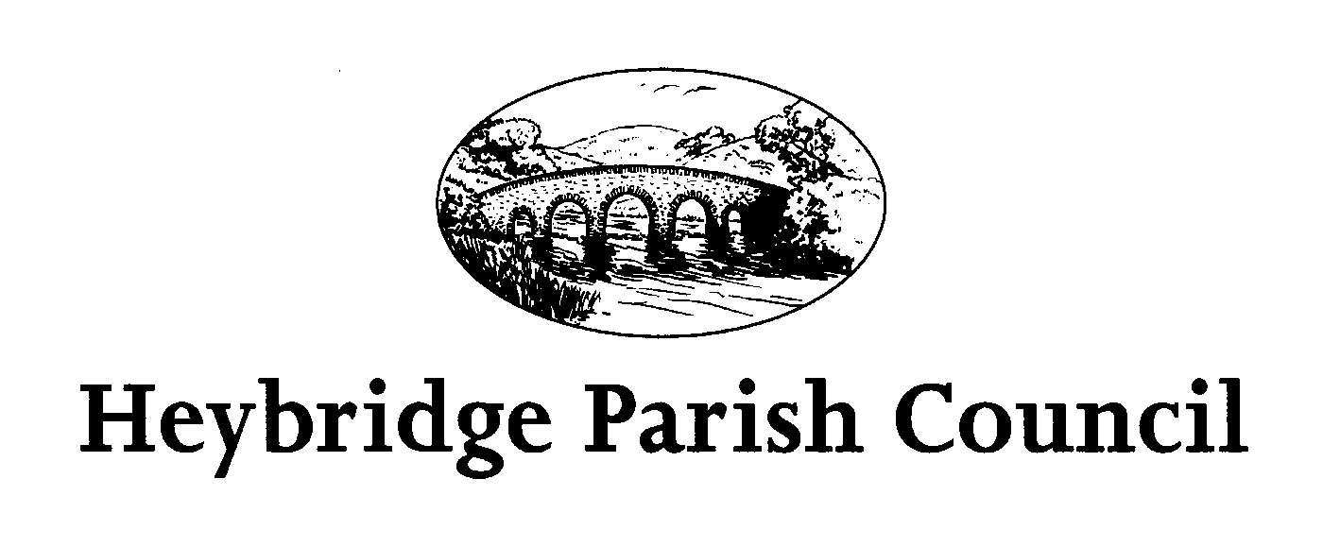
The Public and Press are invited, and all Councillors are summoned, to attend the forthcoming Parish of Heybridge Parish Council. The meeting will be held on Tuesday 8th October 2024 at 1.00pm in the Claydon Room, Plantation Hall, Colchester Road Heybridge where the under-mentioned business is proposed to be transacted.
Due to confidential business, this meeting is not open to the press or members of the public (Public Bodies (Admissions to Meetings) Act 1960, s1 (2)).

Amanda Hilton
Amanda Hilton
Clerk to Heybridge Parish Council 3rd October 2024

AGENDA

- Apologies
To receive apologies.

- Minutes
To receive and confirm minutes of the Budget Meeting held on Monday 30th
September 2024 (to be circulated)

Interests
To receive declarations of interest in accordance with the council’s Code of Conduct. Unforeseen interests must be declared similarly at the appropriate time.

4. Budget Review
a) To receive updated statement of accounts (to be circulated)
b) To review budget for 2024/2025 and consider any actions to be taken
c) To consider draft budget for 2025/2026 and projections for 2026/2027 and 2027/2028.

5. Future meetings
- The next meeting of the Planning Committee will be held on Monday 7th October 2024 at 7.00pm.
- The next meeting of the Events Committee will be held on Monday 14th October 2024 at 7.30pm.
- The next meeting of the Parish Council will be held on Monday 21st October 2024 at 7.30pm.
- The next meeting of the Environment and Facilities Committee will be held on Monday 28th October 2024 at 7.00pm.

