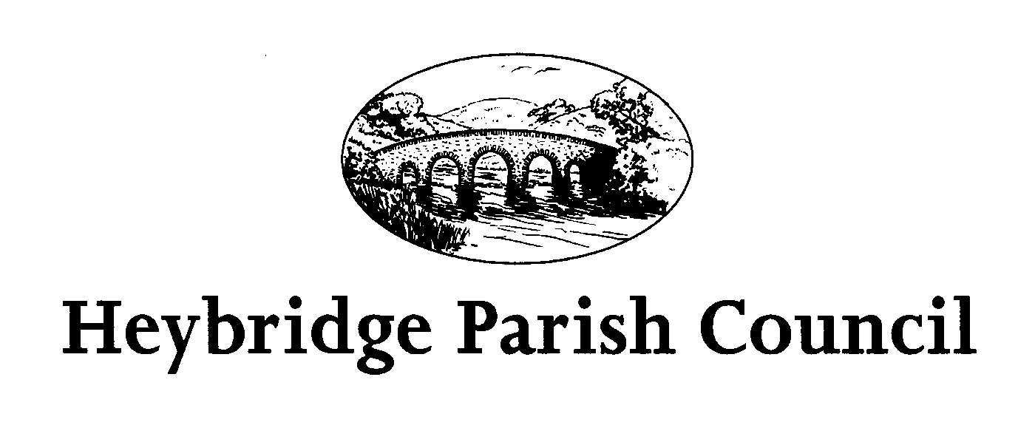
Calendar of Events 2025

Sunday 13th April Children’s Easter Egg Hunt
Plantation Hall 11.00am-1.00pm

Thursday 8th May VE Day Celebrations Times to be confirmed

Sunday 13th July Heybridge Summer Fair
King George V Field 10.00am-4.00pm

Saturday 13th September Open Air Cinema, Film TBC
King George V Field 7.00pm

Sunday 26th October Children’s Treasure Hunt
Plantation Hall 11.00am-2.00pm

Sunday 9th November Remembrance Parade
Parade from Plantation Hall 10.35am

Sunday 7th December Christmas Lunch
Plantation Hall 11.00am

Sunday 14th December Christmas Fair
Plantation Hall 11.00am -4.00pm

For more information contact 01621 852471 or email admin@heybridgeparishcouncil.gov.uk

