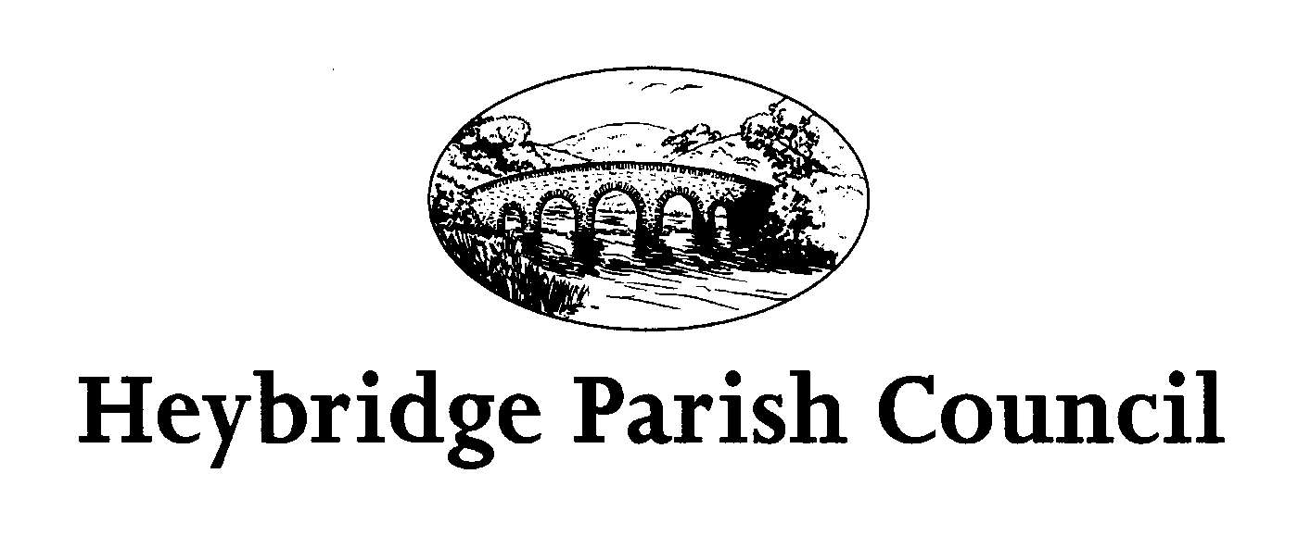
Notice of Annual Parish Meeting

Notice is hereby given that the Annual Parish Meeting will be held in The Main Hall
Plantation Hall, Colchester Road, Heybridge on MONDAY 15th April 2024
The meeting will commence at 7:00pm and will be chaired by the Chair of Heybridge Parish Council

The agenda is set out below, and it should be noted that only those persons present at the meeting who are currently registered as local government electors for the Parish of Heybridge may exercise a vote on any issue so put.

All presentations are subject to confirmation.

AGENDA

1. Welcome.
2. To receive and confirm the Minutes of the Annual Parish Meeting held on Monday 22nd May 2023 (minutes can be found on the Parish Council Website)
www.heybridgeparishcouncil.gov.uk

3. Chairs report including Financial Summary.

4. To receive presentations from:
a) G Dyer ASB Officer – Community Engagement Officer
b) Barry Harding – Community Champion
c) Simon Burwood- President of Heybridge Blackwater Rotary Club
d) Jean Blair – Community Volunteer

5. Open Forum for the public to raise any matters of interest.

6. Close of meeting.

