WARM HUB DATES
Wednesday 31st January 2024
Wednesday 28th February 2024
Wednesday 27th March 2024
10.00am – 2:00pm
Community Space @ Plantation Hall
Pop along, meet your
Parish Council Community Engagement Officer,

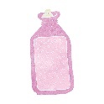

Receive a free Cosy Community Bag.
Refreshments will be served.

