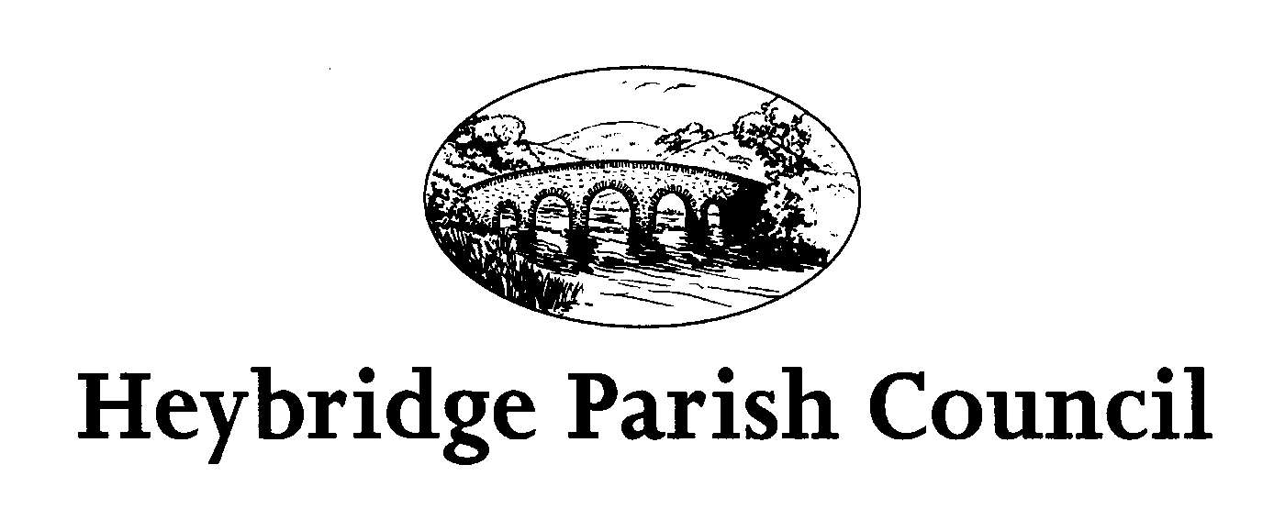
Minutes of the meeting of the ANNUAL PARISH MEETING held on Tuesday 19th April 2022 in the Main Hall, Planation Hall, Colchester Road, Heybridge.

Chairman Councillor Richard Perry
Councillors Ashley Jones Trevor Cable
Miriam Lewis Zimrul Alam
Diane Gibson Mark Salisbury
Carey Martin

District Cllrs Anne Beale Paula Spenceley
Bruce Huebner

County Cllr Mark Durham

Officers Amanda Hilton Clerk
Karen Harley Financial & Administration Officer
Public 2
Representatives Maldon District Council – Gary Dyer ASB Officer
Stuart Clarke Community Engagement Officer,
Heybridge Neighbourhood Group – Mike Childs
Friends of Cemetery Group Miriam Lewis
Community Champion Barry Harding

In the Chair Richard Perry

1 Introduction and Welcome
The Chairman welcomed everyone to the meeting. The Chairman updated everyone of the sad loss of Cllr Bernard Hall and asked them to stand up and join him in a minute’s silence.
2. Minutes

The minutes of the Annual Parish Meeting held on 20th May 2019 were
received.
It was RESOLVED the minutes of the Annual Parish Meeting held on 20th May 2019
be approved and signed by the Chairman.

3. Parish Council Annual Report for 2018/2019 and Statement of Parish Council Account for year ending 31 March 2019

Cllr Perry read his report for 2021/2022. Cllr Perry’s report included an overview of the Parish Council. Cllr Perry included a report on Parish achievements 2021/2022 which highlighted the work of the council within the community and associated public events.

4. District Councillors and County Councillors Reports
The Chairman welcomed County Councillor Durham to give his report. Cllr Durham
gave an explanation on how Council Tax is divided and confirmed that 74pence went to the County Council, 12pence to the District Council, 1pence to the Parish Council,
13 pence to the Police with 2/3 of the County Council amount going towards Social Care, 43pence towards adult social care and 13pence towards child social care.
Cllr Durham confirmed under the Locality Fund he had awarded the Parish Council with funding to clean Heybridge Cenotaph that looked spectacular following the work. Cllr Durham said the Locality Fund would be changing this financial year to
award County members with £5000 to be allocated to their wards and a further £5000
to be pulled with other district divisions.
Cllr Durham confirmed the Local Highway Panel were looking for applications and
explained the Street Improvement Scheme.
Cllr Durham said he would update members when he had further information on a scheme that was due to be reintroduced to tackle potholes. Cllr Durham said that Cllr Scott would be happy to attend Parish Council meetings.
Cllr Durham confirmed he would be happy to take any questions.
Cllr Jones asked if the white and yellow road markings along Hall Road and Heybridge Street could be covered under at Local Highway Panel Request.
Mike Childs asked Cllr Durham for an indication as to when the District Council would be back open to the public. Mike Childs confirmed he had been waiting for over a year from the Planning Department for a response. Cllr Durham confirmed the District Council Office had been used as a Vaccination Centre, with staff working from home which had an impact of the service delivered. Cllr Durham said that he shared the concerns that there may be a hybrid way of working going forward.
Barry Harding asked if under the Street Improvement Scheme two local roads could be considered for resurfacing.
Cllr Lewis updated Cllr Durham with regards to an incident that happened in Beeches Road where it had been turned into a temporary construction compound. Cllr Lewis
confirmed she had been successful in getting the compound removed but asked Cllr Durham to seek assurance how the County Council assists the parish council and its residents when developments are taking place.
Cllr Lewis also reminded Cllr Durham, part of planning permission for the NHGS
included Sustainability with regards to public transport. Cllr Lewis confirmed, the 288
extension previously funded by the parish council would stop operation on the 23^{rd of} April 2022 which would Heybridge West Ward without a bus service. Cllr Durham confirmed he would look into both matters and come back to members.

5. Presentations

Presentations were received from:
Gary Dyer, ASB Officer Maldon District Council.
Gary confirmed he was the ASB Officer embedded within the Community Engagement Team, and he worked closely with Essex Police. Gary confirmed that he understood ASB was an emotive subject and reassured everyone that it is taken very seriously. Gary confirmed that he worked closely with the Clerk and Karen. Gary thanked members for the donation of a TV for the Tea and Toast sessions.

Cllr Lewis confirmed that she had never met such an active member of the team and Gary had been invaluable with some recent matters in the parish and his work was an example of excellence.

Stuart Clarke, Community Engagement Officer Maldon District Council.
Stuart confirmed that the team had been very proactive and updated members with
the latest TRUCAM figures.
Stuart confirmed that Heybridge had a great sense of community, and he enjoyed actively patrolling the area and engaging with the community and being able to educate them in a positive way and being a visible presence.

Miriam Lewis, Friends of Heybridge Cemetery.
Miriam thanked members for the invitation to give a brief introduction to the Heybridge Friends of the Cemetery that had been formed in 2018 and had given a group of families a sense of purpose, meeting up once a month to help look after the cemetery and most importantly, each other.

Barry Harding, Community Champion
Barry thanked members for the support they have shown him and gave special thanks to Mandy and Karen for all their help. Barry confirmed that between 2021-2022 he had collected over 500 bags of rubbish, and it was just getting worse.
Barry confirmed that he was holding regular community litter picks and the next one was planned for 15th May 2022.

Barry confirmed that there were areas that needed to be tackled regularly and asked council if it would be possible to install extra bins around the parish to assist with this. The Chairman asked Barry to liaise with the Clerk with suggested sites.

Cllr Jones thanked Barry for his constant dedication to the keeping the parish tidy.

Mike Child Heybridge Neighbourhood Group.
Mike confirmed that the group has been established in 2003 to help improve the local area and had planted 24 trees since then around the parish and in 2009 the group had won the Anglia in Bloom Bronze award for their efforts.
Sadly, Mike confirmed due to a few factors the group had disbanded but he and Mrs Childs would always be prepared to support the parish council.

The Chairman thanked Mike for his support over the years.

6 Open Forum

The Chairman passed on his condolences to the family of the late Councillor Bernard Hall who was a much loved and respected member and would be sadly missed.

The Chairman thanked all those that attended and closed the meeting at 8.53pm.

