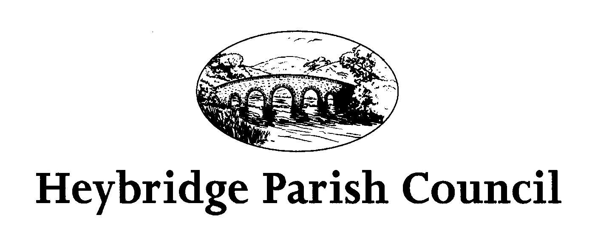
Information and Communication Technology Policy
Social Media, Email, Networking
- Introduction

  - Information and Communication Technology (ICT) is central to everything that the Parish Council does. It is integral in the day to day running of the Council.

  - Social media offers a range of opportunities for local councils to use the internet to communicate and engage with local residents.

  - The Parish Council can make use of social media to:-
- Improve communication
- Increase participation in Council work
- Help change the culture of the Council, to be more open, transparent and collaborative
- Reduce costs

  - Blogging and Social Networking are effective methods for Councillors to interact with parishioners. Used effectively, they can engage those who would not normally have access to local councillors.

  - It is vital that all parties are aware of the safeguarding issues surrounding the use of ICT.

- Legal considerations:
- Human Rights Act 1998
- Data Protection Act 1988
- Regulation of Investigatory Powers Act 2000
- Defamation Act 2013
- The Parish Council’s Code of Conduct
- Other Parish Council’s policies

- Acceptable Use of ICT for Councillors
  - All Councillors must take responsibility for their own actions when using the internet and email, and must exercise care and consideration at all times.
  - It is the personal responsibility of every Councillor to take all reasonable steps to make sure they follow the conditions set out in this policy.
  - Any comments made on social media should not represent or purport to represent the Parish Council on the internet. Postings about the Parish Council or individuals within the Council are not allowed.

- Data Protection and Monitoring
  - The Council’s Monitoring Officer may, at any time, monitor social media use by Members.
  - The Parish Council has a legal duty to meet regulations of Data Protection legislation.

- Intellectual Property
  - The use of intellectual property belonging to the Parish Council is strictly forbidden outside of official capacity. This includes the use of the Parish Council logo.
  - All Members are reminded that the title of Councillor belongs to the Parish Council.

- Social Media
  - The Parish Council operates a Council website which is administered solely by the Parish Clerk.
  - The Parish Council operates a Facebook Page which is administered solely by the Parish Clerk.
  - The Community Engagement Officer operates a Facebook Page which is administered solely by the Community Engagement Officer.

- Personal/System Security
7.1 User accounts and passwords are strictly for the use of the registered user and should not be shared or made accessible to others. It is not acceptable to use anyone else’s username and passwords.

7.2 Do not give out personal details to anyone via email.

7.3 It is important to respect the privacy of other users as well as be polite and appreciate that others may have different views to your own. Any use of strong language, swearing or aggressive behaviour is not permitted.

- Status of Policy
This policy will be considered for adoption by full Council on the 20th November 2014. Adopted 20 November 2014. Reviewed May 2016. Reviewed and agreed 18 May 2017.
Reviewed May 2022
Reviewed March 2023
Adopted 15th May 2023

