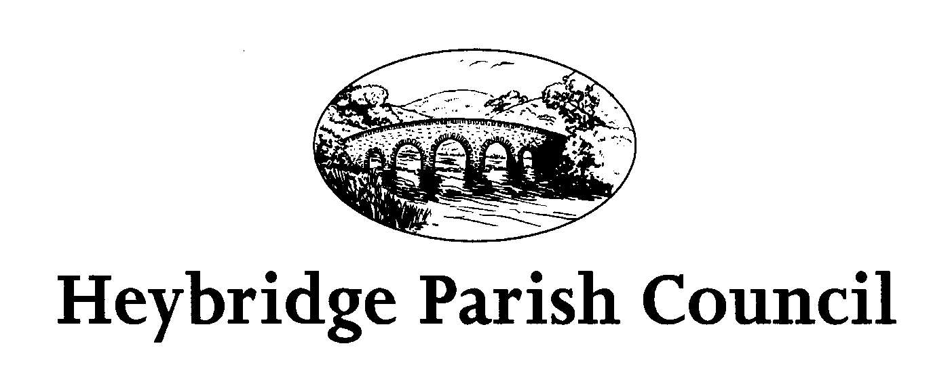
Notice of Annual Parish Meeting

Notice is hereby given that the Annual Parish Meeting will be held in The Main Hall,
Plantation Hall, Colchester Road, Heybridge on TUESDAY 19TH APRIL 2022
The meeting will commence at 7:00pm and will be chaired by the Chairman, Heybridge Parish Council.

Recording of meetings
Please note the Council may be recording any part of this meeting held in open session. Members of the public attending the meeting with a view to speaking are deemed to be giving permission to be included in the recording.

The agenda is set out below, and it should be noted that only those persons present at the meeting who are currently registered as local government electors for the Parish of Heybridge may exercise a vote on any issue so put.

All presentations are subject to confirmation.

Cllr Richard Perry – Chairman of the Council
12th April 2022

AGENDA

1. Introduction and Welcome – Cllr Richard Perry (Chairman of Heybridge Parish Council)

2. To receive and confirm the Minutes of the Annual Parish Meeting held on Monday 20th May 2019 (appendix 1).

3. Parish Council Annual Report for 2021/2022 by the Chairman, and a statement on the Parish Council accounts for year ending 31 March 2022 by the Clerk to the Parish Council (to be circulated).

4. To receive reports from the District Councillors and County Councillor.

5. To receive presentations from:
a) G Dyer ASB Officer – Community Engagement Team
b) S Clarke – Community Engagement Team
c) Miriam Lewis – Friends of the Cemetery Group
d) Barry Harding – Community Champion
e) Heybridge Neighbourhood Group

6. Open Forum for the public to raise any matters of interest.

7. Close

